**Simmer Design Document: Real-Time Cooking**

Updated as of January 31st, 2022

Real-Time Cooking

Cooking itself will initiate when the player selects the recipe they want to begin in the kitchen HUB. To prevent the player from committing to a recipe they cannot complete, there are certain skill and ingredient checks to prevent the player from wasting time. The player then navigates the kitchen taking items and equipment to each station. Timers will be displayed over time-sensitive stations (such as a pot of soup on the stove) and the player will have to execute each step of the recipe. Checkmarks will be displayed on the recipe card after the completion of certain steps. The player will have to finish the recipe regardless of quality before they can leave the apartment. If the player ignores the recipe and does not complete it before the day is over, the player will fail the recipe and receive the lowest score. The total time of completion will be accounted for on the global time tracker.

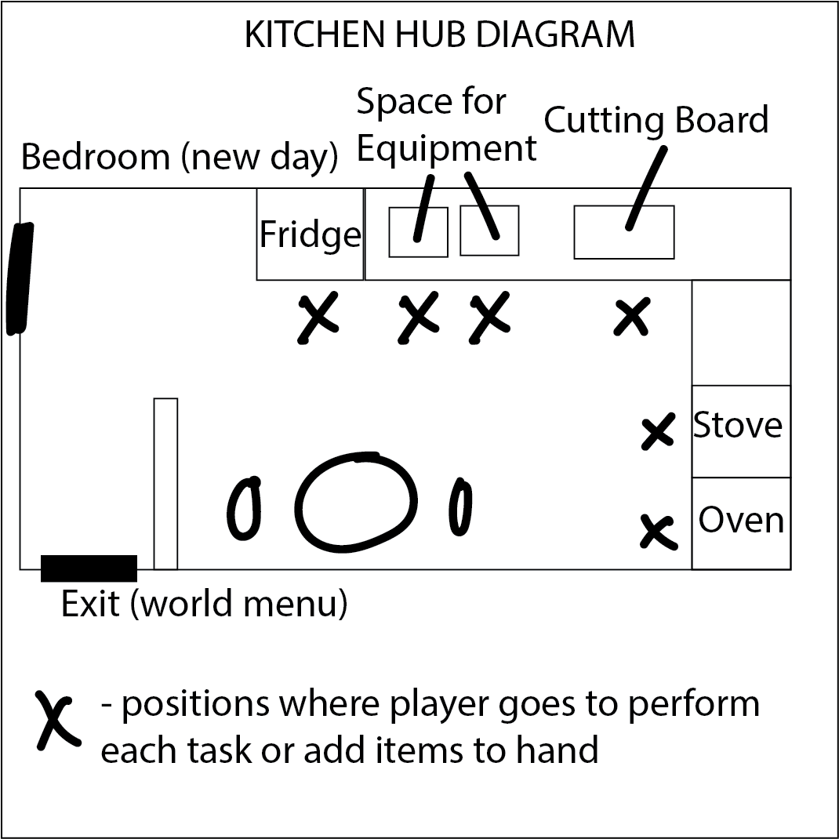

Priority List for Week 5:

1. Oven
2. Mixing Station
3. Pantry/Fridge
4. Assembly Station
5. Cutting Board
6. Stove

Appliances

* Cutting Board
  + Accepts single item
  + Player interacts at station over a period of time to *chop* item
* Mixing Station
  + Accept multiple items (Max # ingredients to start: **4**)
  + Player interacts at station over a period of time to *mix* items
* Stove
  + Accepts multiple items
  + Combined item begins heating
  + Timer
* Oven
  + Accepts single item
  + Timer

**Objective:**

The oven should be able to take an ingredient, cook it for a certain amount, and produce the associated outcome to the recipe. Otherwise, the oven produces the placeholder "burnt item". The oven should operate in this fashion to hide the changing state of the item and rely on time.

1. Pass an item into the stove
2. Initiate cooking timer via player input (a button of some sort to begin)
3. Cover the item visually to hide the changing state of the object
   1. Specifically so the player must use the timer as reference to tell if the item is done or not
4. Finish cooking the item by pressing a button (preferably in the same position as first button) revealing the item
   1. If the correct item was placed in and cooked, the correct item should be revealed to take out
5. The revealed item can be taken out of the oven

* Pantry/Fridge
  + Stores ingredients
* Assembly Station
  + Compile ingredients together
  + Validate final dish